Website Evaluation Report  
Website Chosen for Evaluation: https://www.dndbeyond.com/  
  
Introduction  
  
List of Main Tasks  
**Goal**: Find a magic item for a level 5 rogue  
**Task 1**: Where can I find information on rogues  
**Task 2**: What magic items are in the game?

Task Annotations  
Screenshot with Main Tasks Circled: 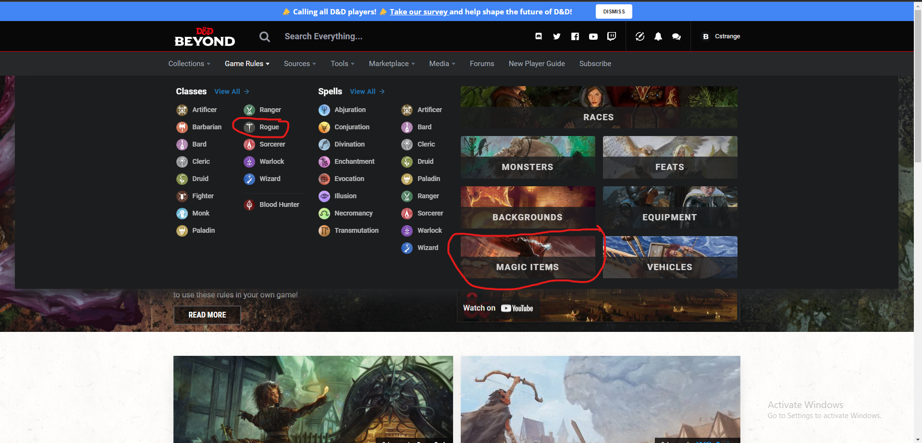

Explanation: I circled the rogue class button because that is where you would find the ruleset regarding rogues. I also circled the magic items button because that is where you would find all of the magic items in dnd.

Visual Attention Analysis (With Color)  
Explanation: I circled those three areas because those are the areas that stood out to me when I did a quick glance at the page.

Visual Attention Analysis (Without Color)  
 Explanation: I circled those three areas because those are the areas that stood out to me when I did a quick glance at the page.

Comprehensive Annotations  
Discussion: For what I was trying to accomplish some of the tasks were the most prominent. The problem is that the ‘goal’ I had was one of hundreds that someone who visits the page might try to accomplish. There would be no reason to make my niche tasks the most prominent things on the page. But some like the magic items were pretty high up on the list of things that stood out.

Design Analysis  
**Scanning**

* *Reading Order:* Most prominent things were on the right side of the page, you would  
  notice some less prominent ones on as your eyes were drawn to the right.
* *Hierarchic Scan:* All class items were grouped up, same with spells and then other categories were grouped together to the right.
* *White Space:* Not a lot of white space is being used.

**Layout**

* *Alignment*: Groups were aligned centered but items inside the groups were left aligned
* *Balance*: Well-balanced equal amount of stuff on all sides

**Fonts**:

* *Consistency*: Webpage followed the same format
* *Font as Information Not as Art*: Some of the font is small but otherwise very readable.
* *Avoid Centered Text*: No centered text, I am happy.